CS-3083 Project 2 Report

Bradley Titagwan

Task 1: Game Of Connect.
Part 1: Alpha-Beta Pruning Search Design
Overall Design.
The AB search was built using the minimax foundation, where, for optimization, we had to prune branches of the game tree that cannot possibly affect the final decision-making of the agent. Maintaining alpha and beta, the agent can skip evaluating sub-trees once it finds a move that is worse than a previously examined option.
The Evaluation Function and Piece Distribution.
The core of my agent is its heuristic evaluation function. Since I used a timer for how long the agent can think, I implemented iterative deepening, where, depending on how much time the agent was given to think, it would provide the best result it had reached. So, the agent used a scoring system to eliminate the “strength” of the non-terminal states.
Since four in a row was the terminal state, the function was to look across the board for any four similar cells, whether horizontally, vertically, or diagonally.
The weight distribution in favor of the agent was 4-in-a-row, worth 10,000 points; it is an Immediate win. 3-in-a-row with 1 empty in any direction is worth 1000 points, and 2-in-a-row with 2 empty is worth 100 points.
In the score position function, I added six extra points for placing a piece at the center of the board because it gave the player an extra advantage. At the center, there are more winning combinations, whether it is vertical, horizontal, or both diagonals.
Then I also had to add a weight distribution, where the agent will prevent the other player from winning. If the other player had 3-in-a-row with 1 empty in any direction, the agent’s score will drop by 950 points, which would cause the agent to neutralize that spot.
The scores reflect the possibility of success. A high positive score indicates the agent has multiple avenues or “open” lines where a win is mathematically more likely, while a low or negative score indicates the other player, in this case, the human is dominating the board.

Balancing Responsiveness versus Smartness
As said above, since a timer was used, iterative deepening was used to keep the agent as smart as possible. The agent starts searching from Depth 1, then 2, and so on. After examining each depth completely, it checks if the time has elapsed. If the time is about to elapse or has elapsed, the agent returns the best move found at the last completed depth. When I first started writing the code, I discovered that a fixed depth of 7 took about 1.5s, which was very fast. So, switching to iterative deepening, the more time I gave the agent to run, but less than 1.5s, the agent became smarter. At times 1.5s and above, the agent was practically impossible to beat as an average human because it could forecast the game to the end, which most of our human brain can’t.
I also discovered the pruning efficiency increased as the game kept on because from move 10 and up, the depth level examined increases from 5 to 6 and then 7 towards the end of the game. It clearly shows that at the beginning, every move is roughly the same but around the middle and towards the end of the game, there are distinctively good and bad moves, and any fault from either party gives the other a chance of victory. 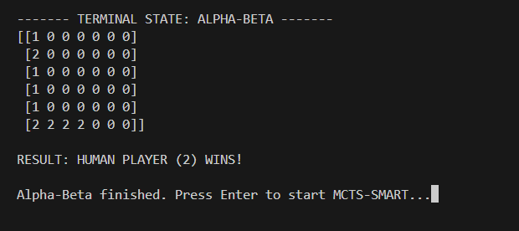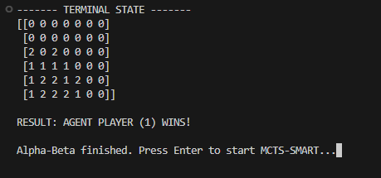

Part 2: Monte Carlo Tree Search (MCTS) Design
Overall Design.
Unlike the alpha beta search, the Monte Carlo tree search has no heuristic. It works by building a lopsided tree based on favoring moves that have higher winning rates in random simulations. This process follows a four-step cycle of selection using the UCB1 equation (), expansion, simulation ( exploring various playouts), and back-propagation.
Playout Policies: Random versus Smart
For the implementation and comparison of two policies, I chose the random and the smart playout.
For the random playout logic, the agent operates as an “uninformed” explorer, utilizing pure randomness to evaluate the potential of the game state. During the simulation phase which is where the playout logic comes into play, the agent selects moves with equal probability, completely unaware of the board’s strategic layout or immediate threats. It does not prioritize winning sequences nor does it block an imminent victory by the opponent. Instead, it relies on the law of large numbers. While it is computationally faster because of less logic, this policy requires a high volume of simulations to filter out the "noise" created by irrational random moves that would never occur in a real game.
In contrast, for the smart playout logic, the agent incorporates the domain "knowledge" to create more realistic and reliable simulations. Rather than playing blindly, the agent does a one-step look-ahead before every move in the simulation. It first checks for any move that would result in an immediate win; if found, it takes it. Then, if no win is available, it looks out for any possibilities of the opponent winning and prioritizes blocking them. Only when no immediate wins or losses are detected does it fall back to random move selection. With that rationale, the smart policy ensures that the win/loss statistics returned to the tree are based on high-quality gameplay. This significantly reduces the variance of the data, allowing the MCTS agent to converge on the optimal strategy much faster and with fewer total simulations than the Random policy.
Parameter Tuning: The Exploration Constant( symbol C)
I tuned the constant C in the UCB1 Formula $\frac{c. wins}{c.visits}+C+ \sqrt{\frac{log⁡(nodes visited)}{c.visits}}$ .
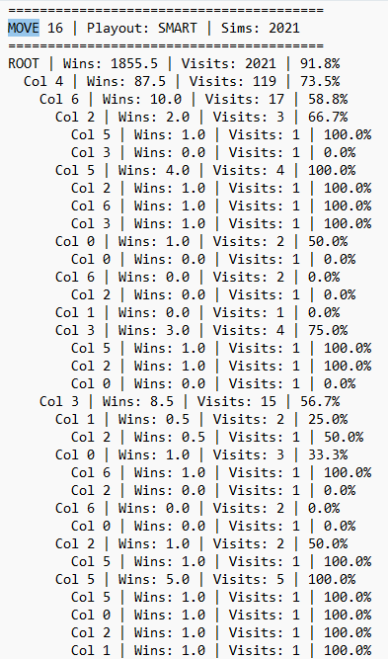
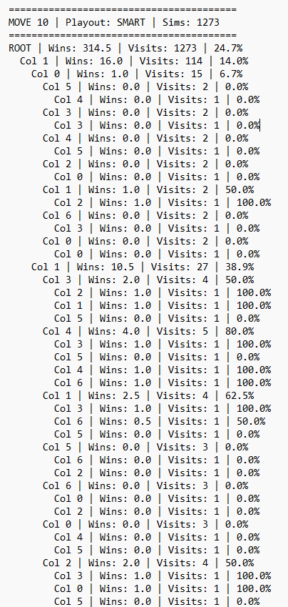
At C = 1.41, the agent balanced exploring new columns and exploiting winning ones, but at C= 2, the agent became too curious and often ignored a winning path to check less visited nodes, leading to losses. If we take a look at the snapshot for the second-to-last move of the game, when C = 1.41 and 2.0 respectively below. The winning rate when C = 1.41 of the root node at that point is 91.8%, whereas that when C = 2.0 is 24.7%, which is very low and means the agent is more likely to win in the first scenario and not the second.
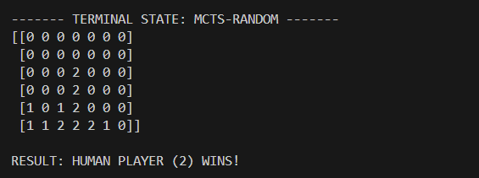
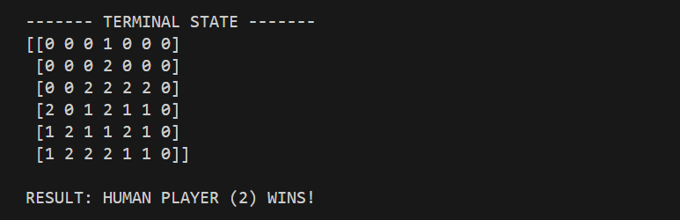
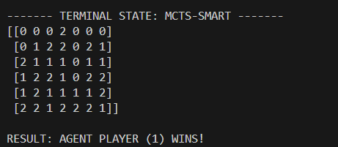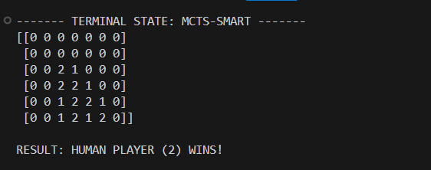

Task 2: Sudoku Solver.
Introduction
The objective of the task was to implement a Constraint Satisfaction Problem(CSP) solver to solve Sudoku problems of various block sizes. The project involved implementing a standard recursive Backtracking algorithm to optimize the solver.
Method Of Implementation.
The solver was implemented as a Backtracking search for the CSPs. The implementation treated each cell as a variable. The domain was 1 - 9, and the sudoku rules were the constraints (row, column, and block).
The CSP structure of the three key decision-making stages, variable and value selection, with inference and the contingency clause of backtracking were used.
Variable Selection is deciding which empty cell to fill next. Inference predicts the future consequences of a move before making it. Value Selection is deciding which number to try first in the chosen cell.
Efficient Data Structures
For the effective management of the state and metrics of the board (N x N grids), I utilized NumPy 2D arrays. It allowed rapid manipulation and sub-grid slicing. Also, neighbor sets were very useful because they allowed for a pre-computed set of coordinates for the row, column, and block of every cell. Reduced the lookup time from O(n) for a list to O(1) for a set. Lastly, I implemented a backtracking counter to quantitatively measure search effort across different configurations.
Performance Analysis
Variable Selection: MRV vs. Random (9 x 9, 40 Empty Slots)
I tested the solver on boards with 40 empty slots to isolate the impact of cell selection.
I found out that MRV (Minimum Remaining Values) significantly outperformed Random selection. The MRV took less time and had no backtracking in comparison to the random selection. MRV successfully identifies the "most constrained" cell or the cell with the fewest legal moves left.

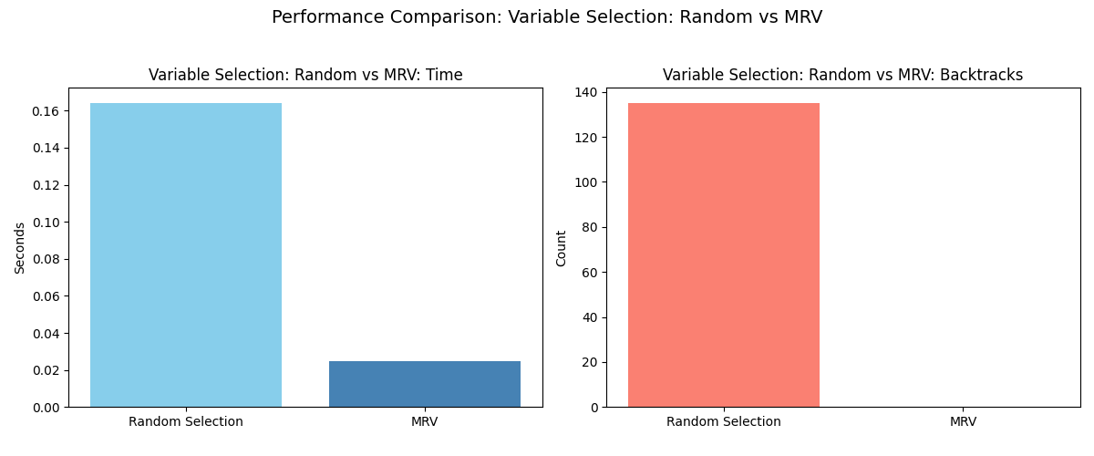
By selecting the hardest cells first, the agent triggers "Fail-First" logic. If a branch is impossible, MRV finds that contradiction immediately, whereas Random selection often wanders deep into an invalid branch (thrashing), resulting in higher execution times and thousands of backtracks.
Inference: Forward Checking (FC) vs. MAC (9 x 9, 60 Empty Slots)
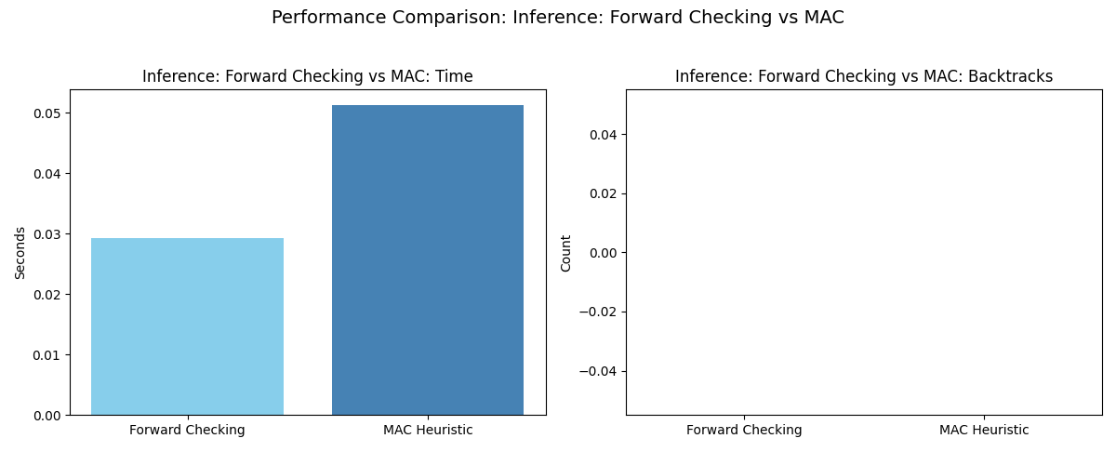
After testing the inference on boards with 40 empty slots, I could not come up with any reasonable conclusion because there was no backtracking, and the times were relatively the same, so I updated the board with 60 empty slots. to isolate the impact of cell selection.
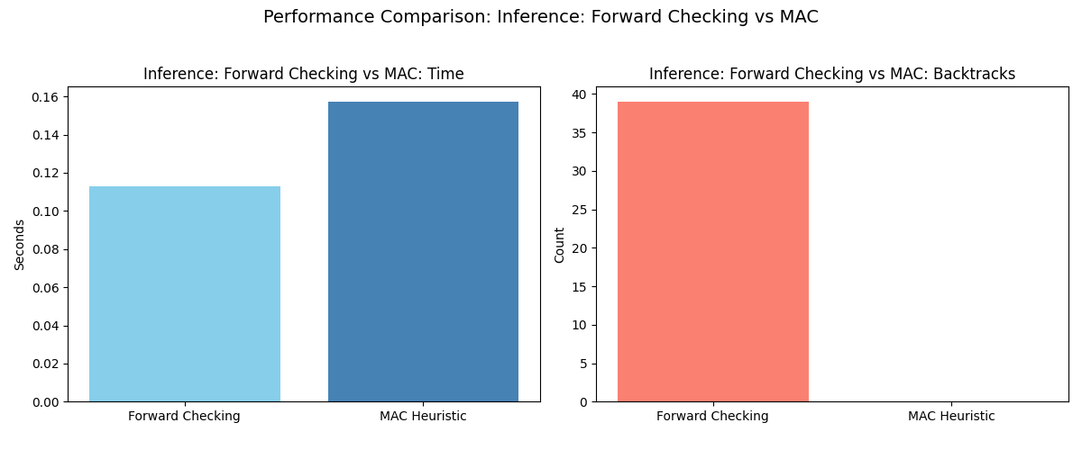
With 60 slots, I found out that MAC (Maintaining Arc Consistency) had no backtracks but took longer than forward checking. I concluded that even though forward checking backtracks, less computational time and cost are significant for an effective search since CPU and storage are limited resources

Value Selection: Standard Order vs. LCV (9 x 9, 60 Empty Slots)
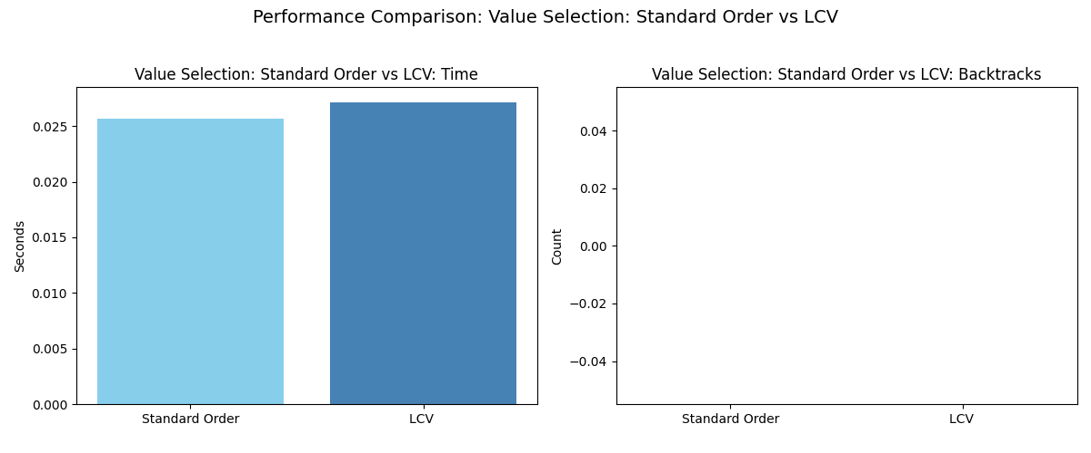
Same as the inference testing, the value selection testing on boards with 40 empty slots could not provide enough data to come up with any reasonable conclusion.
For a board with 60 empty slots, Standard Order (1–9) outperformed the LCV in execution time while maintaining zero backtracks. It is because the LCV (Least Constraining Value) attempts to pick the "friendliest" number by simulating its impact on neighbors. In our tests, once MRV and FC were active, the search space was already so narrow that the first valid number found (Standard Order) was almost always correct. Calculating LCV scores added unnecessary processing time for no search-depth benefit.
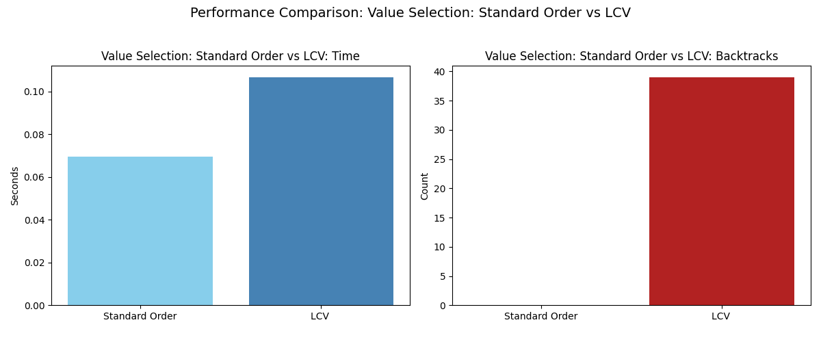
5. Experimental Scalability
While FC and Standard Order were the winners for 9 x 9, scalability testing show the following:
- Node Density: As the number of empty squares approaches 200+ in 16 x 16, we quickly see the constraints become more diffuse.
- Heuristic Reversal: In these cases, the "Overhead" of MAC and LCV begins to pay off. Even though on the 9x9 board, LCV was slower than the standard order, in a 16 x16 and 25 x 25 board, the extra time spent on MAC's arc consistency prevents a "wrong" choice that could lead to millions of backtracks that FC would not catch. Thus for large Sudoku problems like 25 x 25, MAC is likely the scalability winner for massive grids.
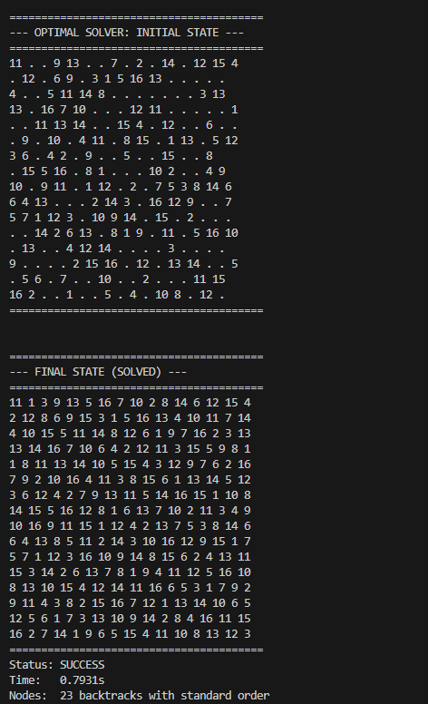
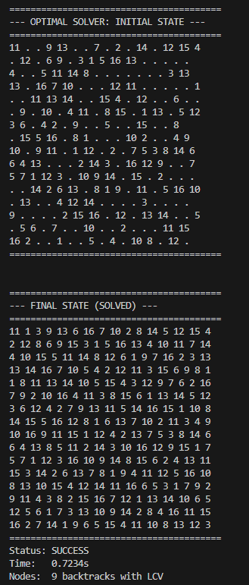

Summary Of What I Have Learned
- Heuristic Dominance (MRV): Implementing the Minimum Remaining Values (MRV) heuristic was the most significant optimization. It transformed the search from "uninformed" to "informed" by picking the most constrained cells first, effectively acting as a Fail-First strategy that prunes invalid branches at shallow depths.
- Inference Efficiency (FC vs. MAC): I discovered the "Efficiency Frontier" between Forward Checking (FC) and Maintaining Arc Consistency (MAC). While MAC is theoretically more powerful, FC proved superior for $9 \times 9$ puzzles because it achieved the same zero-backtrack result with significantly less computational overhead.
- Heuristic Redundancy: My testing revealed that some advanced heuristics can become redundant. Once MRV and FC were active, the search space was so narrow that Standard Value Order (1–9) performed better than Least Constraining Value (LCV) because it avoided the extra calculation time LCV requires.
- Scalability & NP-Completeness: The project illustrated how search space complexity grows exponentially. While a 9 x 9 board (81 squares) feels near-linear with heuristics, the 25 x 25 board (625 squares) demonstrates the true nature of NP-Complete problems, where every single reduction in the branching factor is vital.
- Algorithmic Synergies: I learned that heuristics work best in "pincers." MRV reduces the depth of the search by finding contradictions early, while FC reduces the breadth by removing invalid future moves, leading to a perfectly efficient path to the solution.

